**TEST PLAN AND OUTPUT**

1. Choose an option between 1 to 3 for login access

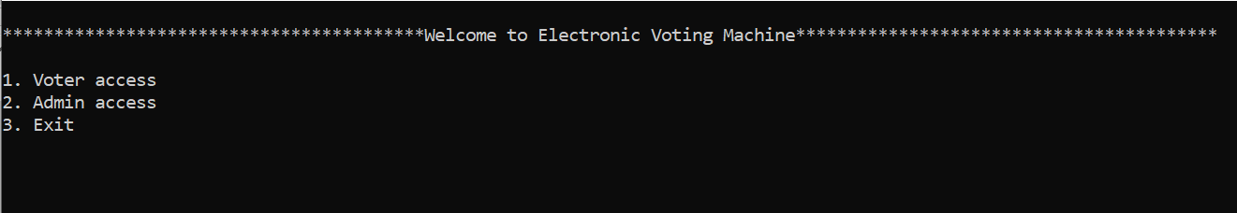

1. Enter 1 for voter access

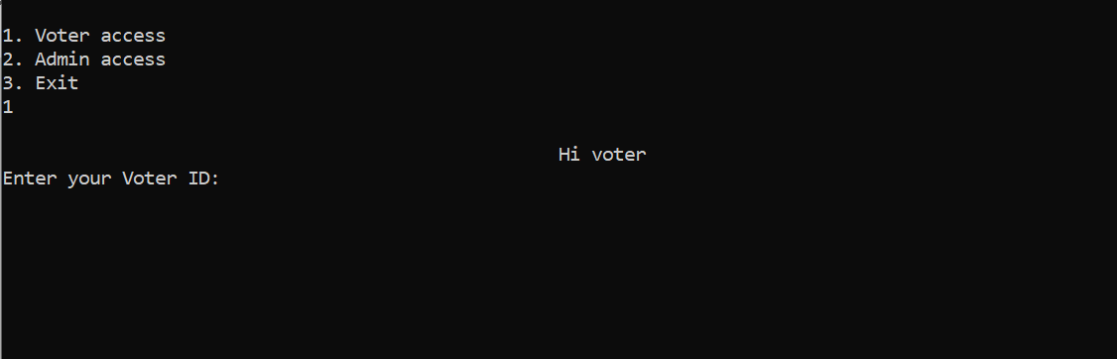

1. Enter the voter Id

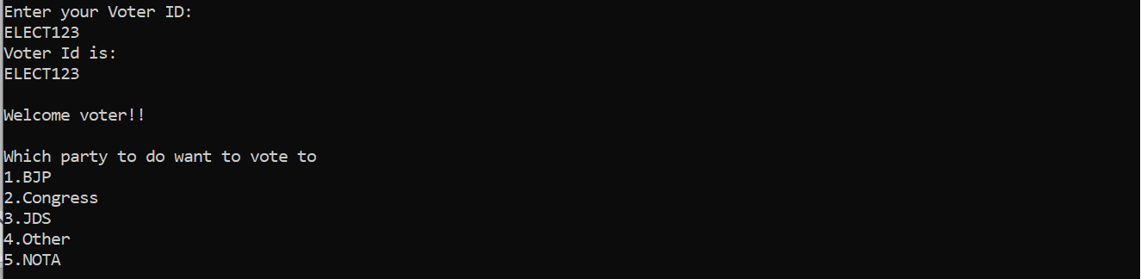

1. Select the party to whom the voter is willing to vote

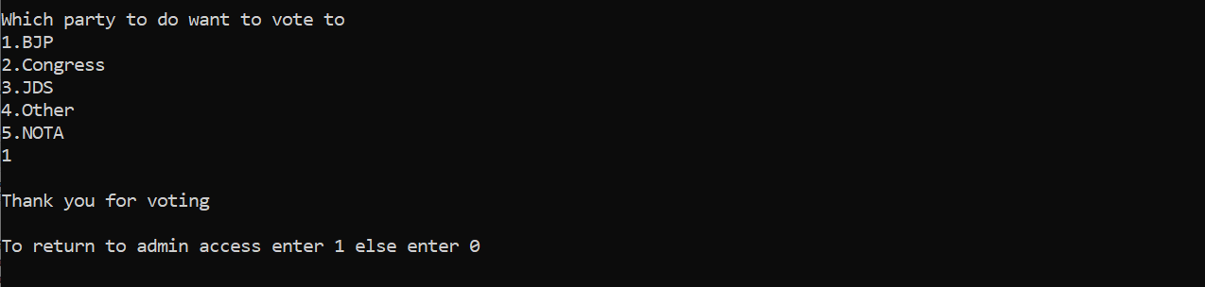

1. To continue the voter access, enter 0

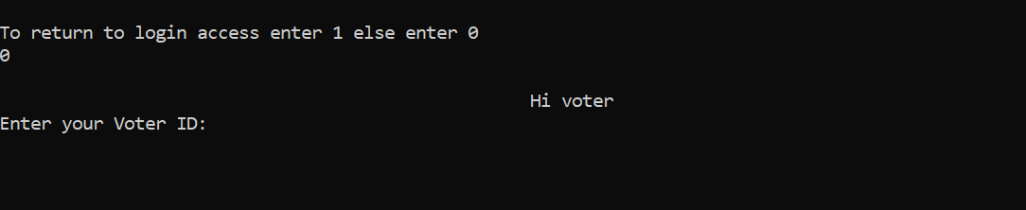

1. If the voter is voting for second time, it will display already voted

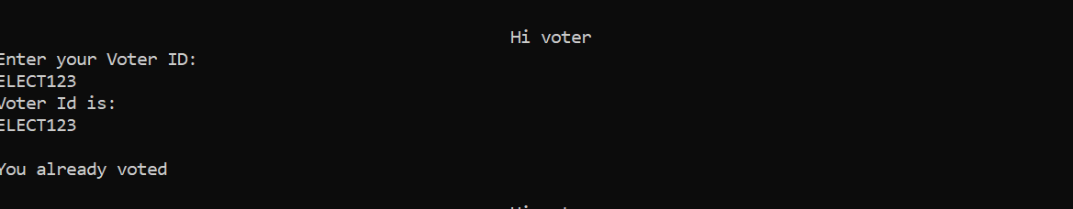

1. Enter 2 for admin access

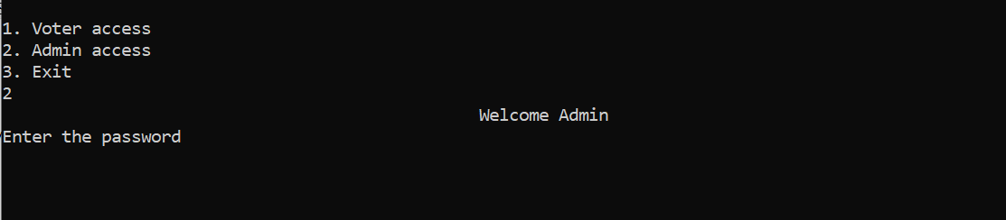

1. Enter the password for login, it will display the number of votes of each party and also displays the winning party.

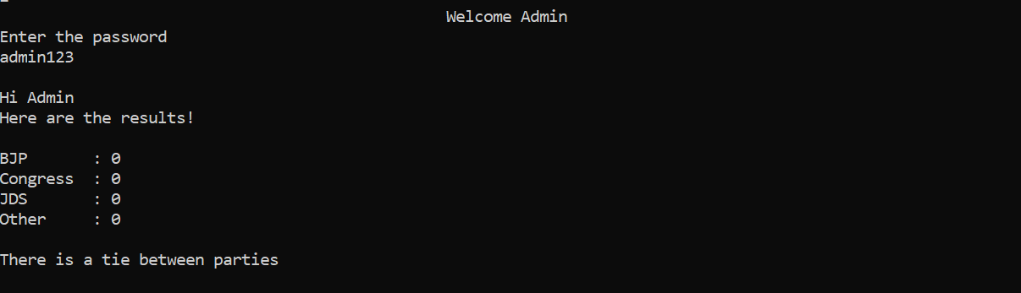

1. If the admin has entered wrong password, it will display sorry access denied.



1. Enter 3 to exit

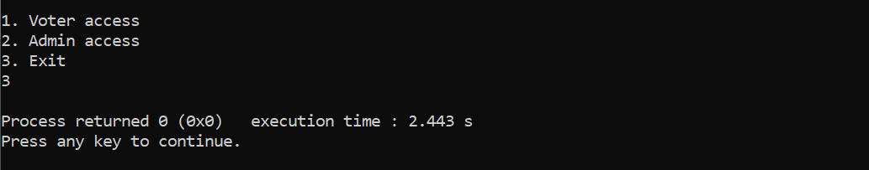

1. If user as chosen except 1 or 2 or 3

